Learn more about user stories.

You’ve already learned about empathy maps and personas and how they can help you empathize with the users you’re designing for. Another helpful way to understand your users is to build a user story around their experiences with your product. As a reminder, a **user story** is a fictional one-sentence story told from the persona’s point of view to inspire and inform design decisions. This is a great opportunity to use your imagination as you create the stories that capture the needs of your users.

User stories should be written in the following format:

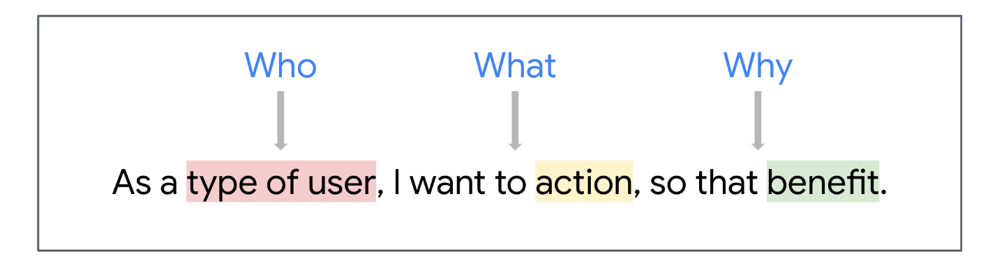A template of a statement framing the WHO, WHAT, and WHY: As a type of user (WHO), I want to action (WHAT), so that benefit (WHY).

As a **type of user** (who), I want to **action** (what) so that **benefit** (why).

Using this format is a clear way to ensure your user story is communicating everything you need to know about the persona. The user stories you create will be very valuable as you start designing your product. User stories can also serve as a “checklist” to make sure you’re addressing and solving the key problems your users might face when engaging with your product.

The best practice for user stories is to keep them short, impactful, and to the point, with a clear action and benefit.

Practice using this format to create user stories related to the dog walker app you've been learning about.



As a frequent traveler, I want to hire a consistent dog walker so that I can feel comfortable about the safety of my pets while I'm on vacation.



As a dog owner, I want to trust my dog walker so I can hire them for regular dog walks.



As a busy executive, I want to trust that dog walkers won't stand me up so I can work worry-free.



As an indecisive student, I want to try many walkers so I can pick one for regular walks.



As a mother of two, I want to limit the amount of access to my home so I can keep my family safe.



As a former police officer, I want to track my dog walker, so I am comfortable with the safety of my pets.



As a widowed executive, I want to find a permanent dog walker, so my pets get the care they deserve.

Keeping these user stories in mind can inform the designs you’ll create. For example, in the dog walker app, users should have the ability to request a date and time for a dog walker, select a specific dog walker, and maybe even read the background checks of dog walkers, since those were all mentioned in our user stories.

Different users have different needs, so be sure to practice empathy and keep their unique needs in mind when writing user stories. To help you write the most effective user stories, check out this article from Interaction Design Foundation about [how to write user stories](https://www.interaction-design.org/literature/article/user-stories-as-a-ux-designer-i-want-to-embrace-agile-so-that-i-can-make-my-projects-user-centered).

**Representing your users**

Personas and user stories represent the needs of the users you’re designing for. The more detailed and accurate your personas and user stories are, the better you will be at designing products that meet their needs. Take your time when creating user stories. Remember, as a UX designer, the user always comes first in all of your work, so it's important to understand their points of view.